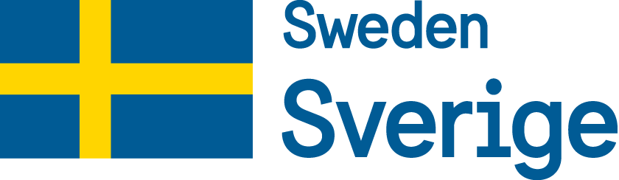
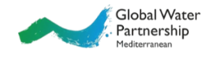
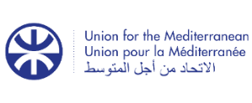
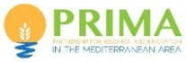

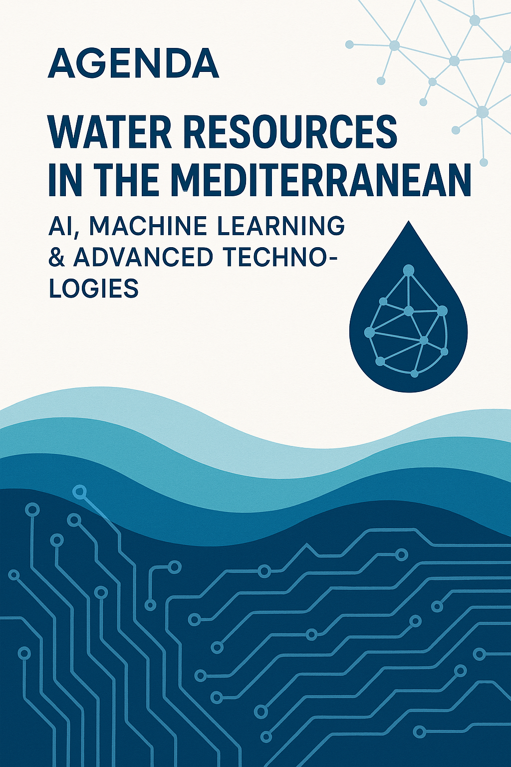

Webinar on

AI-Driven Digital Water Systems:
AI-driven analytics and decision support

Thursday, 2 July 2026
15:00-17:00 CET
ONLINE

REGISTER HERE

WEBINAR ON
AI-Driven Digital Water Systems:
AI-driven analytics and decision support

Thursday, 2 July 2026
15:00-17:00 CET

REGISTER HERE

Please join through ZOOM:
https://us02web.zoom.us/j/86549949946

Background:

Digitalization for natural resources management refers to the strategic adoption and integration of conventional and innovative digital policies and technologies in sectoral and cross-sectoral domains that contribute to sustainable development objectives. Digital solutions, like Artificial Intelligence (AI) and Machine Learning (ML) can provide substantial benefits to water management as well as to the management of interconnected systems of Water-Energy-Food-Ecosystems (WEFE) in a Nexus approach applied at the Mediterranean Source to Sea continuum. Digital transformation for introducing such solutions at all levels involves, among others, leveraging advanced digital tools, data analytics, innovative technologies and related governance and managerial approaches to optimize the efficiency, sustainability, and resilience of related resources.

The Union for the Mediterranean (UfM) agenda prioritizes the Digital Transformation of the Water Sector, with a strong emphasis on Strategic Planning and Capacity Development. Closely aligned with the objectives set forth towards the 2nd UfM Ministerial on Water, this strategic initiative seeks to leverage digitalization technologies and innovative solutions to enhance water management, improve operational efficiency, and foster greater resilience in water resources. Based on these, the UfM Regional Platform on Water (UfM RPW) approved at its 15th Meeting (5-6 November 2025, Barcelona), welcomed the related Strategic Framework Report and adopted its recommendations.

Furthermore, a regional consultation process is ongoing, aiming to promote digital transformation for advancing WEFE Nexus in the Mediterranean, particularly under evolving climate change impacts. After defining the consultation content and establishing the core cooperation team (February 2024/Tunis), the process included three Regional Roundtables (Lisbon/June 2024, Malta/February 2025 and Rome/March 2026). The consultation includes the identification of related Strengths, Weaknesses, Opportunities, and Threats (SWOT). Based on these, recommendations were developed for promoting digital transformation as a contribution to the upcoming Action Framework of the ‘Strategy on WEFE Nexus in the Mediterranean Source to Sea continuum’. This science-driven consultation involves regional and national decision makers and stakeholders in a Living Lab approach. It is facilitated by the PRIMA ACQUAOUNT, TALANOA-WATER and H2020 TRANSCEND projects, in service of and with the support of UfM and other institutional partners. The process is also supported by the WEFE Nexus Community of Practice in the Mediterranean that is facilitated by the PRIMA WEFE4Med project. Related material can be found online HERE.

In this context, this specific module will contribute to sharing technical best practices, with a strong emphasis on AI-driven analytics, cloud databases, and GIS tools, seeking feedback to guide practical implementation. It will also align the related technical work lines and regional consultations by providing updates and advancing steps towards establishing a digitalization, including data- and analytics-focused, thematic work line within the WEFE Nexus Community of Practice.

The webinar is part of a series of consultations and capacity building activities and follows up the Webinar on ‘AI-driven digitalization solutions for Water and WEFE Nexus in the Mediterranean’ organized on 30 June 2025 and Webinar on ‘AI-Driven Digital Water Systems: Strategic Digital Governance and Policy in a WEFE Nexus approach’ organized on 11 March 2026. It is organized by the UfM in synergy with GWP-Med, PRIMA and IME. HYDROC GmbH provides technical content. The activity is supported by the Swedish International Development Cooperation Agency (Sida). The Webinar contributes to the 6th Euro-Mediterranean Water Forum (29 September–2 October 2026, Rome).

Objectives:
- Strengthen technical understanding of AI-driven analytics and decision support for water resources management in the Mediterranean Source to Sea continuum.
- Present architectures and good practices for cloud databases and data infrastructures that underpin AI/ML applications in the water sector.
- Introduce GIS concepts, tools and workflows for integrated water resources management.
- Provide a hands-on introduction to open-access platforms, with focus on Google Earth Engine for hydrological analysis using satellite Earth Observation data.
- Illustrate AI/ML-based decision support for forecasting, risk assessment, scenario analysis and operational water management.
- Share Mediterranean case studies and identify replicable approaches for national and basin-level institutions.

Expected webinar outcomes:
- Participants understand how cloud databases, GIS and Earth Observation can be combined with AI/ML.
- Participants become familiar with the main components and design principles of a modern data and analytics stack for the water sector.
- Participants gain practical awareness of Google Earth Engine capabilities and typical workflows for hydrological analysis (e.g., precipitation, drought indices, surface water, evapotranspiration, land change).
- Participants identify concrete entry points for AI-driven decision support in their own institutional context.

Participants:
Representatives from Mediterranean member states, including:
- National water and other (energy, agriculture, environment, international cooperation) ministries and related regulatory authorities
- Water utilities and basin agencies
- ICT and cybersecurity departments
- Academic and research institutions
- Regional and national stakeholder organizations and practitioners
- Private sector entities involved in water management and technology
- Development partners and donors

Agenda
All times presented are in Central European Time
Time  (CET) | Session/Topic  Presentations will be followed by brief Q/A/. For time efficiency, participants are requested to share their questions in the chat
15:00-15:10 | Opening session  Speakers: Dario Quadri, UfM, Representative of PRIMA, Alain Meyssonnier, Institut Méditerranéen de l’Eau (IME), Vangelis Constantianos, Global Water Partnership-Mediterranean (GWP-Med)  - The role of AI-driven analytics and decision support in the WEFE Nexus in a Mediterranean Source to Sea continuum approach
15:10-15:30 | GIS for integrated water resources management and WEFE Nexus analysis  Speaker: Dr. Georg Petersen, HYDROC GmbH  - Core GIS concepts and data types for water applications  - Spatial analysis for river basins, groundwater and coastal systems  - Integrating GIS with hydrological models and AI/ML outputs  - Open-source GIS tools and cloud-based GIS services
15:30-15:40 | Cloud databases and data infrastructures for AI-driven water analytics  Speaker: Dr. Georg Petersen, HYDROC GmbH  - From sensors and SCADA to cloud: architectures for water data  - Data lakes, data warehouses and interoperability (FAIR data principles)  - Security, governance and cost considerations for cloud deployments  - Building an analytics-ready data backbone for AI/ML
15:40-16:00 | Satellite earth observation for hydrological monitoring  Speaker: Georg Petersen, HYDROC GmbH  - Key satellite missions and datasets relevant to water (Copernicus/Sentinel, Landsat, MODIS, GRACE)  - Variables of interest: precipitation, evapotranspiration, soil moisture, snow, surface water, land cover  - Strengths, limitations and complementarity with in-situ networks
16:10-16:20 | AI / ML-driven decision support for water management  Speaker: Cristi Constantin, HYDROC GmbH  - Typical ML applications: forecasting (demand, inflows, droughts, floods), anomaly detection, classification  - From analytics to decision: dashboards, early-warning and scenario tools  - Explainability, uncertainty and human-in-the-loop decision making
16:20-16:50 | Open discussion and Mediterranean case studies presentation  Speaker / Moderator: Dr. Georg Petersen, HYDROC GmbH  - Selected examples combining cloud data, GIS and Google Earth Engine for water / WEFE Nexus questions  - Institutional uptake: enabling factors and barriers  - Replicability across Mediterranean basins and countries  - Open discussion
16:50-17:00 | Closing session and next steps  Speaker: Dario Quadri, UfM, Representative of PRIMA, Alain Meyssonnier, IME, Vangelis Constantianos, GWP-Med  • Brief summary of webinar conclusions  • Closing remarks

The Strategy was adopted by the 15th Meeting of the UfM Regional Platform on Water (5-6 November 2025, Barcelona), and is part of the Mediterranean Strategy for Sustainable Development (MSSD, 2026-2035) Flagship Initiative which was adopted at the 24th Conference of the Parties (COP24) of the Barcelona Convention (2-5 December 2025, Cairo)

